# STOCKIE.COM

**A Project Report**

***Submitted by***

## Chintan Ruparel (C086)

## Esha Shah (C093)

## Sachi Shah (C094)

## 

***Under the Guidance of***

Prof. Vijayetha Thoday

***in partial fulfillment for the award of the degree of***

**BTI**

**IN BRANCH OF STUDY**

Computer engineering

At



**MPSTME, NMIMS.**

**April, 2021**

## DECLARATION

I, Chintan Ruparel, Esha Shah, Sachi Shah, Roll No. C086, C093, C094 BTI (Computer Engineering), VI semester understand that plagiarism is defined as anyone or combination of the following:

1. Un-credited verbatim copying of individual sentences, paragraphs or illustration (such as graphs, diagrams, etc.) from any source, published or unpublished, including the internet.
2. Un-credited improper paraphrasing of pages paragraphs (changing a few words phrases, or rearranging the original sentence order)
3. Credited verbatim copying of a major portion of a paper (or thesis chapter) without clear delineation of who did wrote what. ( Source: IEEE, The institute, Dec. 2004)
4. I have made sure that all the ideas, expressions, graphs, diagrams, etc., that are not a result of my work, are properly credited. Long phrases or sentences that had to be used verbatim from published literature have been clearly identified using quotation marks.
5. I affirm that no portion of my work can be considered as plagiarism and I take full responsibility if such a complaint occurs. I understand fully well that the guide of the seminar/ project report may not be in a position to check for the possibility of such incidences of plagiarism in this body of work.

Signature of the Students: __________, _____________, ____________

Names: Chintan Ruparel, Esha Shah, Sachi Shah

Roll Nos. : C086, C093, C094

Place: Mumbai

Date: 12/04/2021

## CERTIFICATE

This is to certify that the project entitled “Stockie.com” is the bonafide work carried out by Chintan Ruparel, Esha Shah, Sachi Shah of BTI, MPSTME (NMIMS), Mumbai, during the VI semester of the academic year 2020-2021, in partial fulfillment of the requirements for the Course Database Management Systems.

___________________

Prof. Vijayetha Thoday

Internal Mentor

_______________________ ________________________

Examiner 1 Examiner 2

## Table of contents

|  |  |  |
| --- | --- | --- |
| **CHAPTER NO.** | **TITLE** | **PAGE NO.** |
|  | INTRODUCTION  SCOPE  PURPOSE | 5 |
|  | DESCRIPTION OF MODULES | 6 |
|  | IMPLEMENTATION OVERVIEW & ARCHITECHURE DIAGRAM | 9 |
|  | SOFTWARES/API’s AND DATABASE USED WITH DESCRIPTION | 10 |
|  | ER DIAGRAM | 12 |
|  | DATABASE TABLES | 13 |
|  | GUI/DATABASE SCREENSHOTS | 19 |
|  | CONCLUSION & FUTURE SCOPE | 27 |
|  | APPLICATIONs IF ANY | 28 |

1. **INTRODUCTION**

There are so many young generations of people who are so much interested into financial markets but are a bit afraid of the consequences if they fail. These are the people who wouldn’t want to loose their initial capital. So finding a solution like this was of utmost importance. Here people with 0 experience about financial markets can participate in the market without having to invest their own saving. The platform integrated with Stockie.com have made and innovated a mock trading platform.

**Scope**

The markets have a way and manner of performing these operations and if you don’t abide by them it will result in huge sums of losses. To avoid that we have come up with this. We give you an amount you can buy sell securities as many as you want within your limits with no risk of facing any real losses and gaining whole lot of trading experience with the comfort of your pockets. Gaining experience and trading is more important then just trading. There are so many young generations of people who are so much interested into financial markets but are a bit afraid of the consequences if they fail. These are the people who wouldn’t want to loose their initial capital. So finding a solution like this was of utmost importance. Here people with 0 experience about financial markets can participate in the market without having to invest their own saving. The platform integrated with Twods have made and innovated a mock trading platform.

**Purpose**

The main purpose of this project is for the people who are not willing to take risk in the securities market. Also for the people who are inexperienced and cant risk their capital for them this app will be a blessing in disguise. With the real experience of trading we also have a place for learning about it. With key insights of portfolios of the big bulls it will help our young investors. The Investment bankers play a huge role in the movement of stock prices we also have that embedded in our website so we can track the insights of what the Trading agencies have their take on the stock. So hence this whole thing is a bunch of super useful things for a young investor.

1. **DESCRIPTION OF MODULES**
2. **Splash Screen**

The webpage starts with a designer splash screen which is made using times from javascript and use of baseline CSS, Node.js and express.

1. **Login page**

Our website starts with a login page where the user has to enter his/her email id, password and secure key. This validation is backed up php and mysql where the values entered is checked with the database. If the values are rightly entered the user is able to access the home page else an error message is displayed.

1. **Home page**

Once the user is able to successfully login, he will access the home page.

The home page consists of 3 parts:

* Navbar: This gives the user an option to visit different pages of our website like Place Order, Sell Stock, Superstar's Portfolio, Trade Outlooks, Investopedia, Reports and About Us
* Portfolio: this consists of details of the stocks the person has in the account at the current time like the company name, the quantity, the buy-price, the status i.e the profit or loss and the last traded price which is printed with help of an API. All the calculation is done at the backend side.
* Quiz: This is a different feature of our website where the user can play a quiz and test his knowledge about the market. The questions and the options are fetched from the database. After solving the quiz the user will be able to see his total score and the correct answers.

1. **Place order Page**

The page consists of an Advanced Real-Time Chart Widget which gives us an overview of the stock price of the company the user wants to search.

The user has to search the company he wants to buy from this chart and analyse the lower and upper limit of the stock.

When he is done analysing this, there is a search bar where the user has to search for the company and enter the quantity, lower and upper limit in the form given below. The user also has to enter his secure key for security purpose.

Once he/she has submitted with the right the form secure-key, the total price id checked with the limit available in the database and if it doesn’t exceed the user is able to buy the particular stock and he is redirected to the homepage. Once the user has brought the stocks the prices is the deducted from the limit available and added to the value of purchase.

Here he or she can view that the stock is added into the portfolio. This all is done with the help of a backend code. And if the user is buying an existing stock the quantities updated into the portfolio.

1. **Sell page**

The page consists of an Advanced Real-Time Chart Widget which gives us an overview of the stock price of the company the user wants to search.

The user has to search the company he wants to sell from this chart and analyse the lower and upper limit of the stock. When he is done analysing this, there is a search bar where the user has to search for the company which he wants to sell from the portfolio and enter the quantity, lower and upper limit in the form given below. The user also has to enter his secure key for security purpose.

Once the user has submitted the form the quantity is deducted from the portfolio (if it is less than or equal to the quantity already present in the portfolio) and the price is the deducted from the limit available and added to the value of purchase. The user is again redirected to the homepage and the respective result is shown in the portfolio.

1. **Chart section**

This is the admin side of the website. You are the admin can have two options that is individual chart and comparison chart.

* In the individual chart the admin can select a particular user and then he is able to see the chart consisting of the quantities (quantity available, sell quantity and buy quantity) and the balance, profit, limit available and the value of purchase. He can also see the activity of the user and the last date of transaction. There is a table which consist of the number of stocks that the user has which is under profit or loss. This page is basically to analyse the status of the user.
* In the comparison chart the admin can select two users and then he is able to see a table which compares the user’s stocks. In this table he can see the common companies which the users have bought and also compare the buy price.

1. **Trading Outlooks**

The user can even track the portfolio of The big dogs of the market. Making decisions like them can only make the user like them.

1. **Investopedia**

An encyclopaedia is a book of every knowledge and investopedia is a book of investment knowledge. Here our user can use the insights of knowledge and gain something while learning and experiencing it.

1. **Reports**

Investment agencies often release yearly reports of different securities here you can also track them in a systematic manner.

1. **About Us**

Shows everything about the company and is made with basic html, css and bootstrap.

1. **IMPLEMENTATION OVERVIEW & ARCHITECHURE DIAGRAM**

A limit of 10,00,000 will be set as the opening balance to buying and selling of securities. Every stock entry will be reflected in the portfolio table as soon as you enter the buy tab. All data regarding data the current stock prices are coming from extensive API’s by Trading View. The profit and loss calculation happens by this formula: Profit = CMP-Cost Price * Quantity

The buy of stock will be an add entry in the portfolio table. The sell of stock will be a delete entry in the portfolio. The buying limit will only be modified once the user locks in their gains or losses.

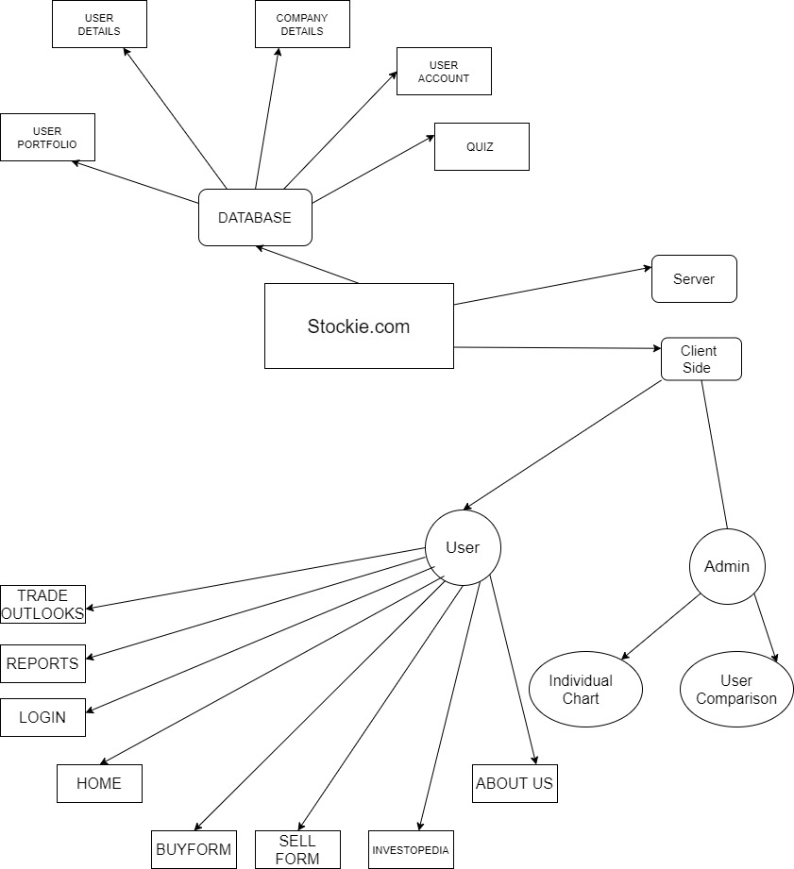

1. **SOFTWARE OR API’s & DATABASE USED WITH DESCRIPTION**
2. HTML and CSS

HTML is the language for describing the structure of Web pages. Design forms for conducting transactions with remote services, for use in searching for information, making reservations, ordering products, etc.

CSS is the language for describing the presentation of Web pages, including colors, layout, and fonts Thus we have used it in designing all our pages of the website.

1. JavaScript

JavaScript, often abbreviated as JS, is a programming language that conforms to the ECMAScript specification. JavaScript is high-level, often just-in-time compiled, and multi-paradigm.

1. PHP and MySQL

PHP is a general-purpose scripting language especially suited to web development. With a MySQL database using SQL, but more often MySQL is used with other programs to implement applications that need relational database capability. PHP and MySQL go hand in hand and thus we used it in the login page, buy and sell stock, searching, user portfolio and on admin side.

1. AJAX

AJAX = Asynchronous JavaScript and XML. AJAX is a technique for creating fast and dynamic web pages. AJAX allows web pages to be updated asynchronously by exchanging small amounts of data with the server behind the scenes. This means that it is possible to update parts of a web page, without reloading the whole page. We used AJAX in search bas.

1. Node and Express

Node.js is an open-source, server side, runtime environment built on Chrome's V8 JavaScript engine. Node js is not a programming language but a Javascript runtime environment which uses JavaScript as programming language on serverside

We cannot connect javascript to database but it can be done through

Node js.

Express is a fast, unopinionated minimalist web framework for Node.js.

Express.js is a web application framework for Node.js. It provides various features that make web application development fast and easy which otherwise takes more time using only Node.js. Express.js is based on the Node.js middleware module called connect which in turn uses http module. So, any middleware which is based on connect will also work with Express.js.

We have used node and express to create our splashscreen.

1. jQuery

jQuery is a fast, small, and feature-rich JavaScript library. It makes things like HTML document traversal and manipulation, event handling, animation, and Ajax much simpler with an easy-to-use API that works across a multitude of browsers.

1. Bootstrap

Bootstrap is a free and open-source CSS framework directed at responsive, mobile-first front-end web development. It contains CSS- and JavaScript-based design templates for typography, forms, buttons, navigation, and other interface components. We used this along with HTML and CSS for the designing and putting different elements in our website for responsiveness.

1. APIs

We have used trading view widgets.

1. IDE

We used Visual Studio Code and Sublime Text for implementing HTML, CSS, JavaScript, Ajax, Node, Express, and Bootstrap. To implement PHP & MySQL, we used XAAMP.

1. **ER DIAGRAM**

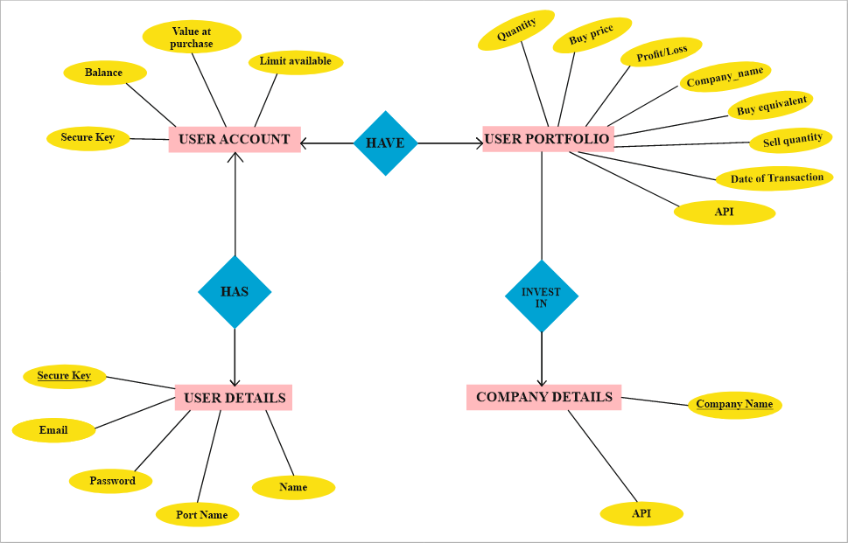

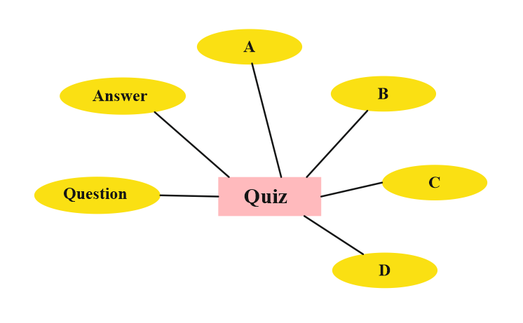

1. **DATABASE TABLES**

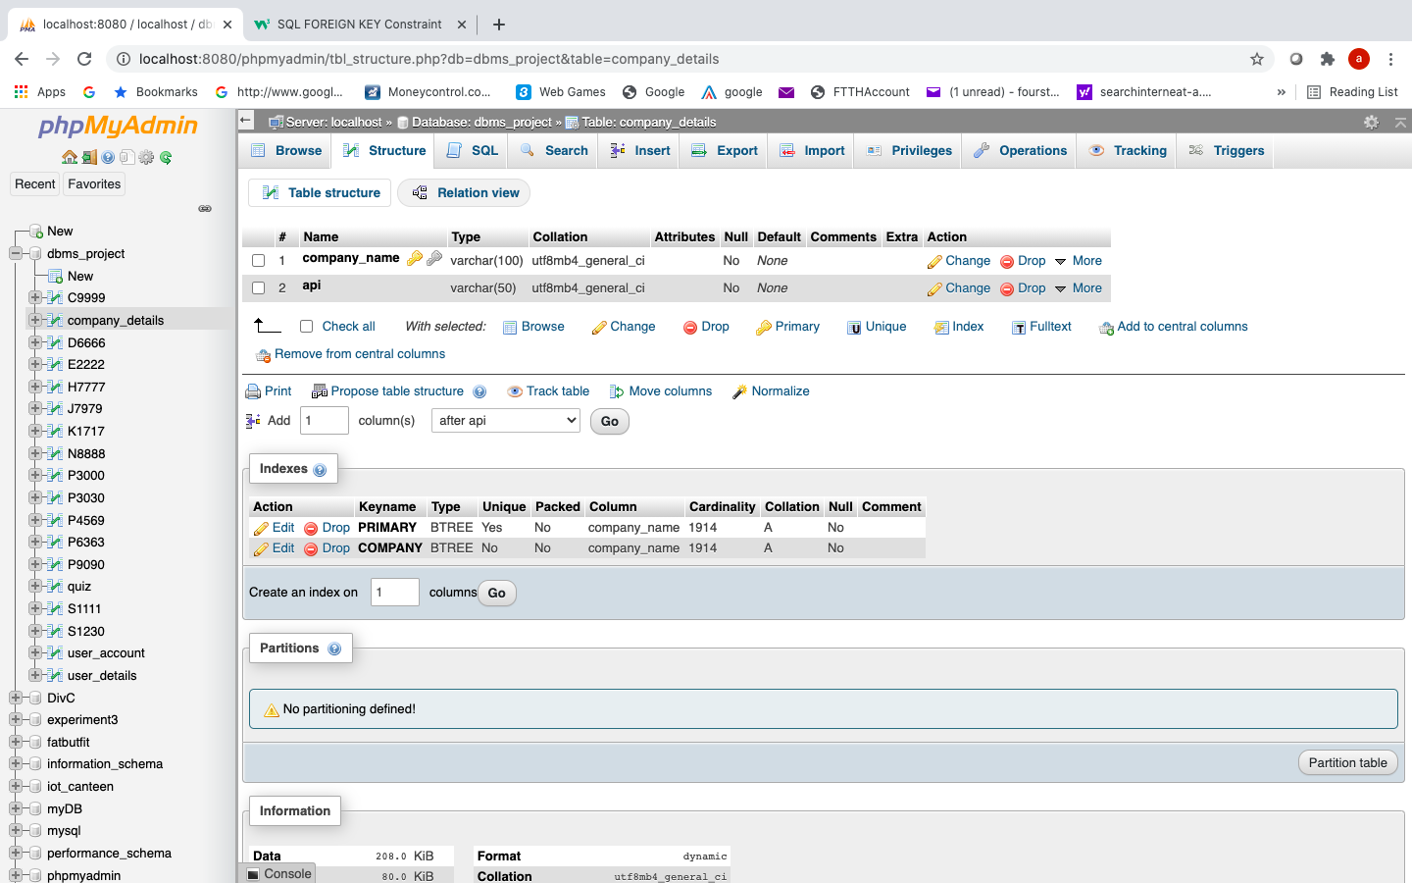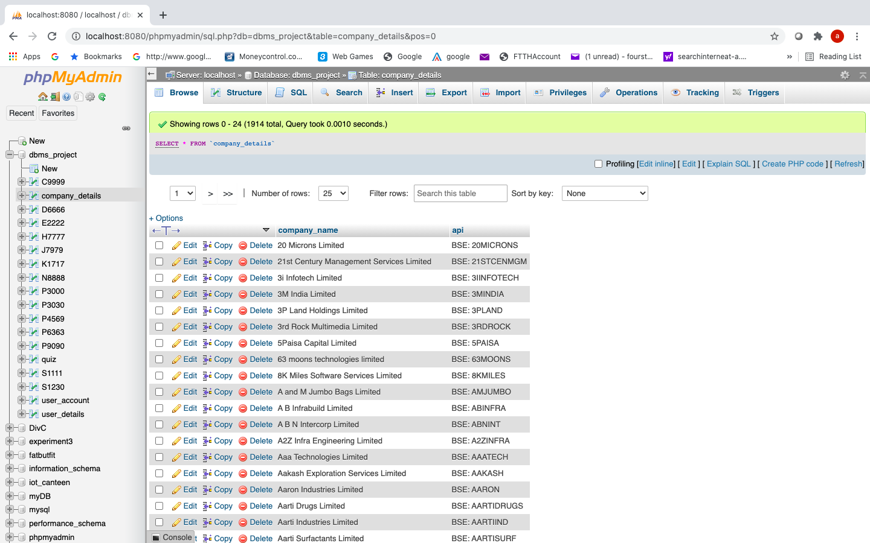

Company detail table

Primary key: company_name

Index on company_name column

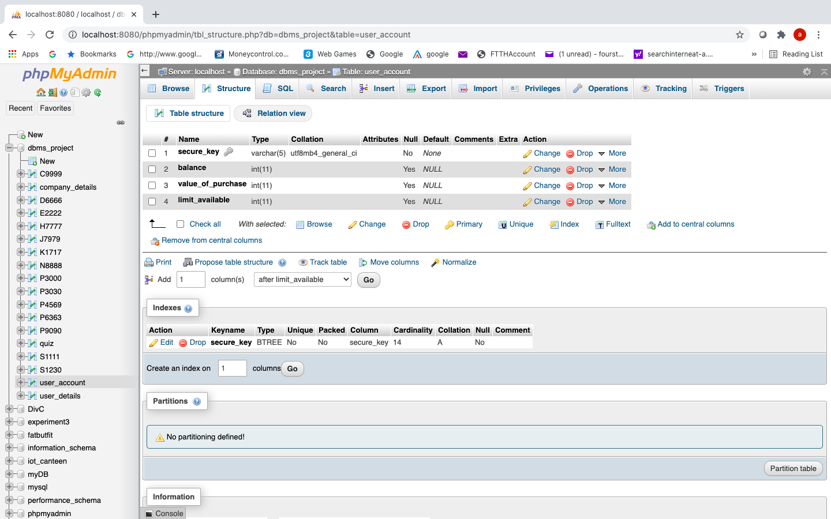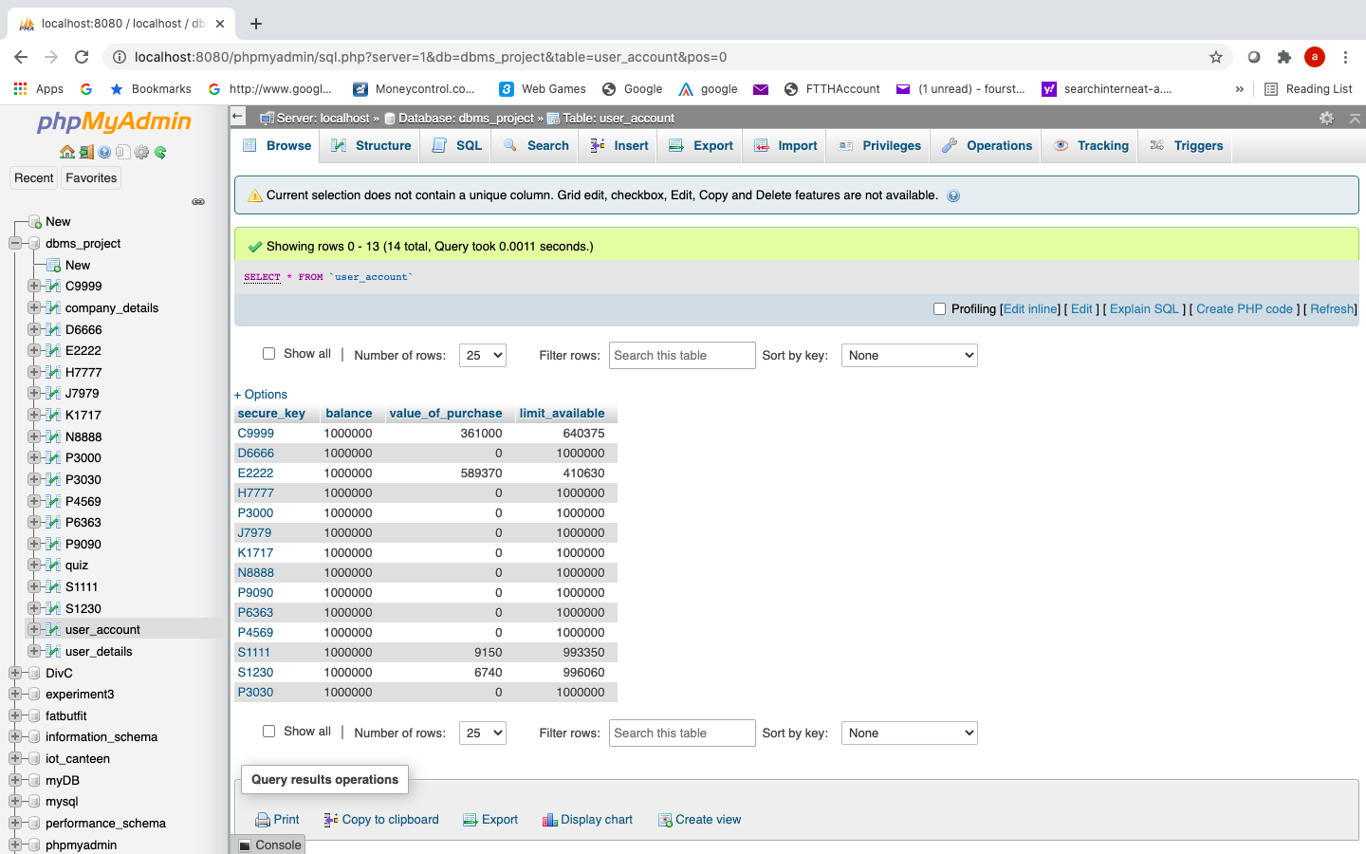

User_account table

Secure_key: foreign key references user_details(secure_key)

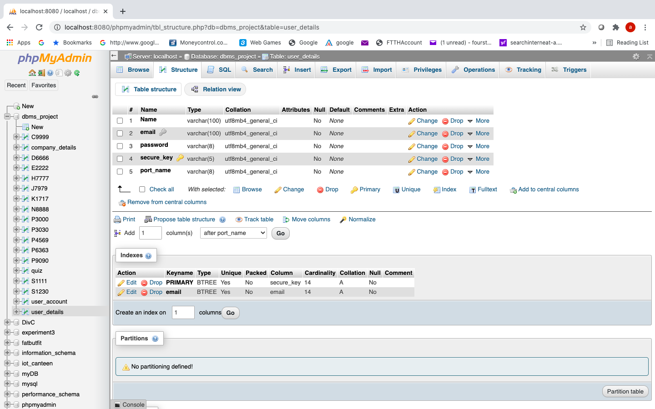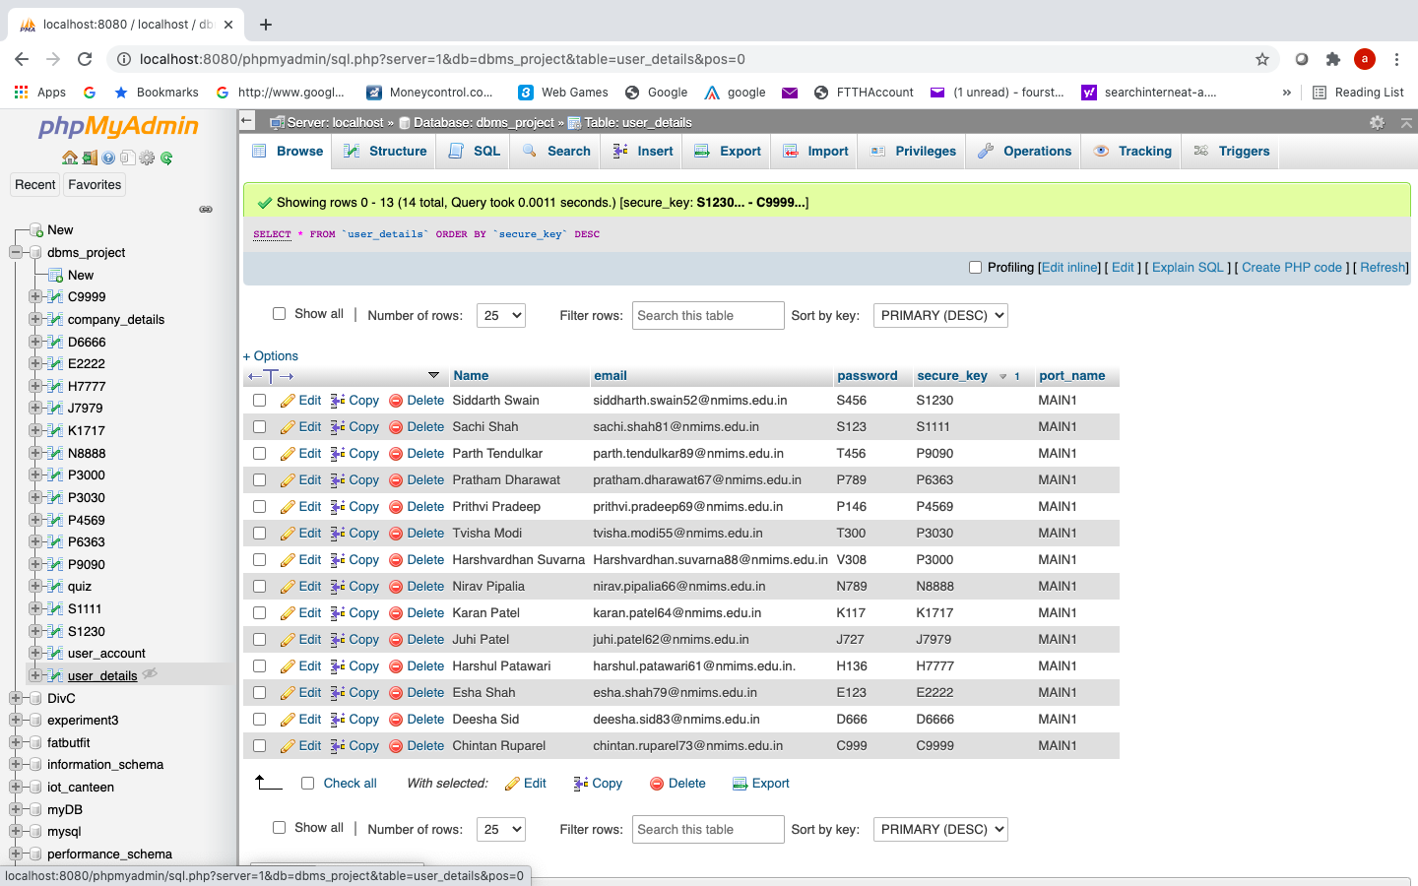

User_details table

Primary: key secure_key

Email: unique

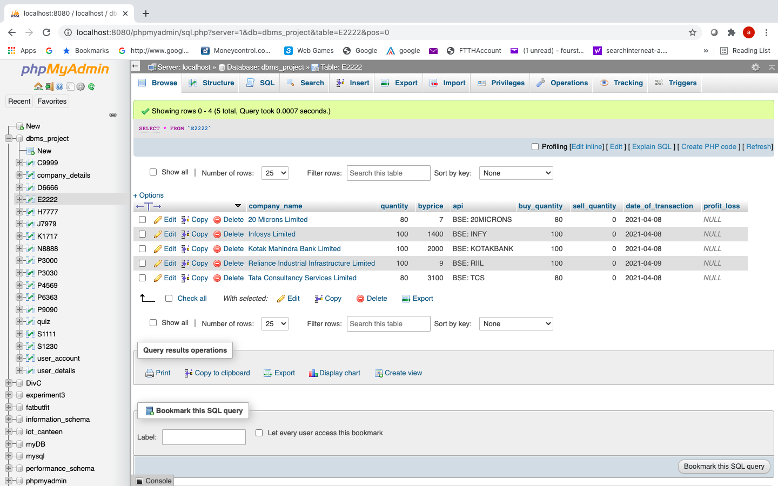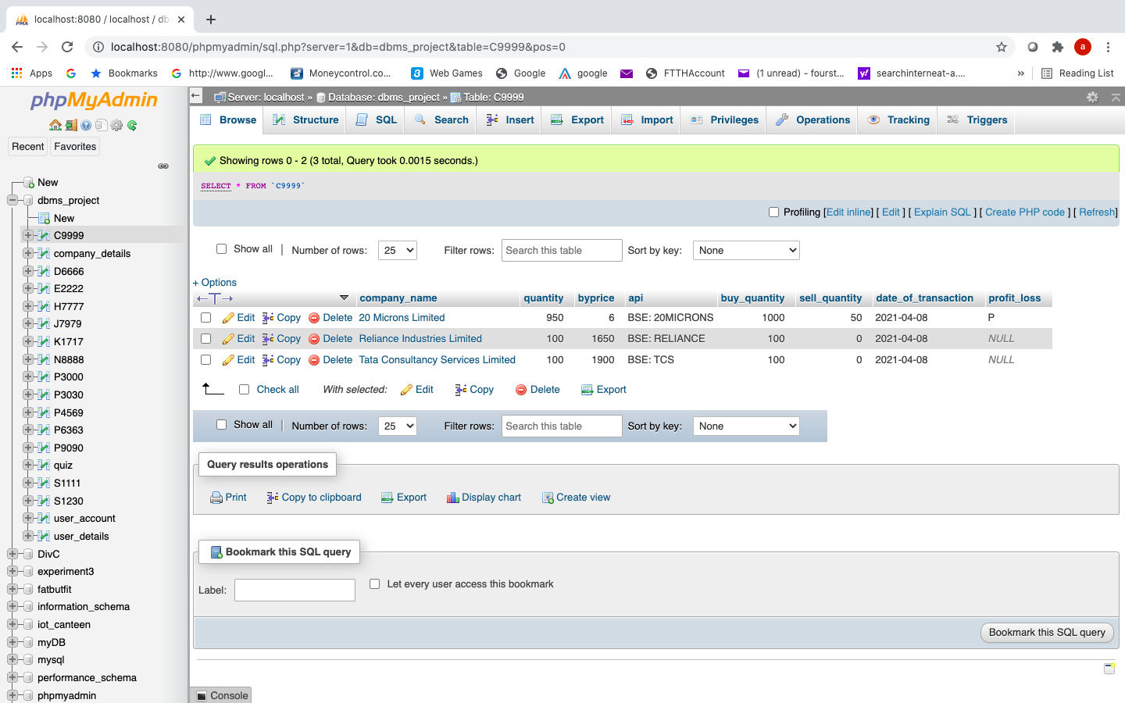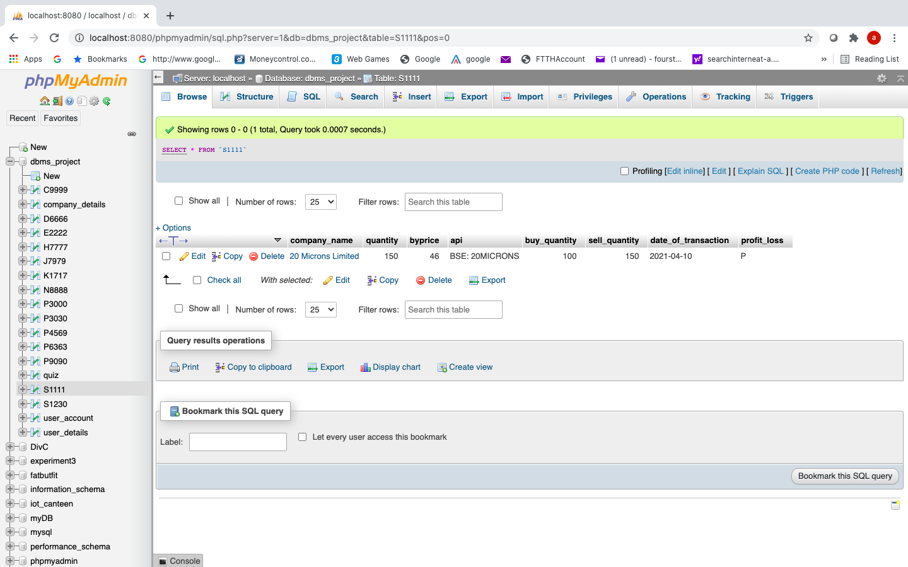

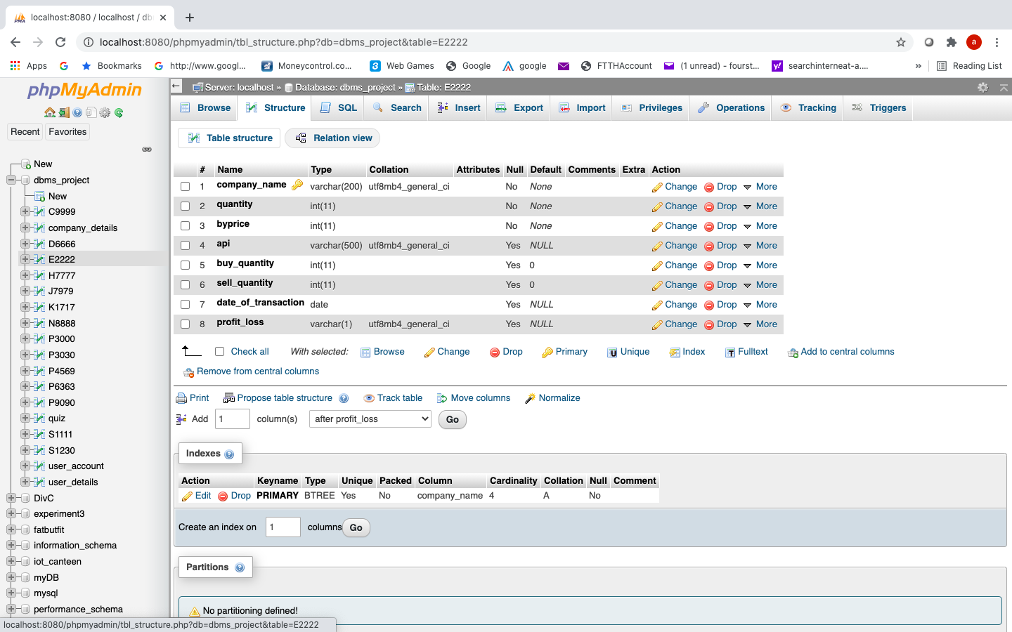

User portfolio table

Company_name: foreign key references company_details(company_name)

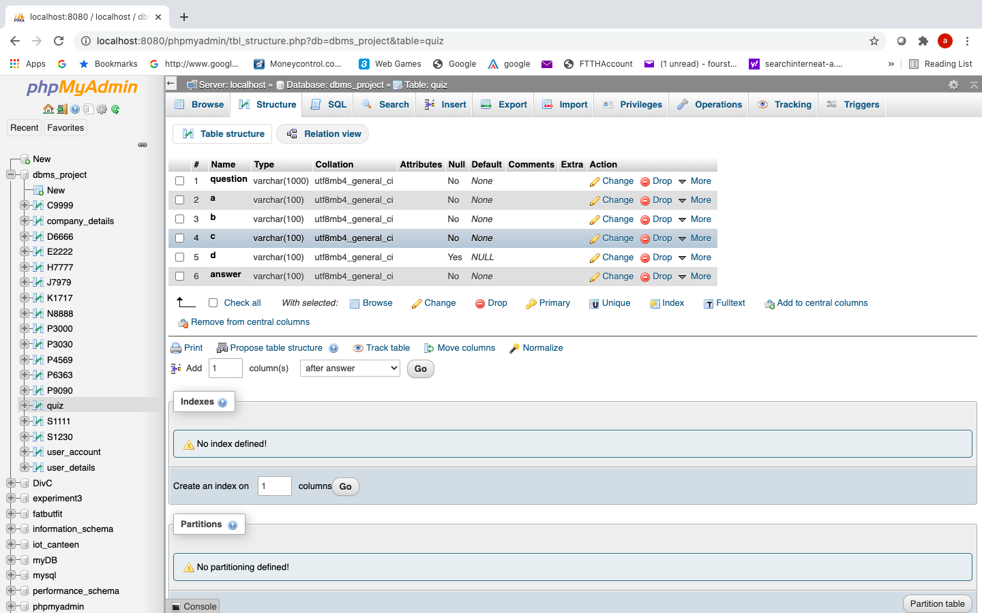

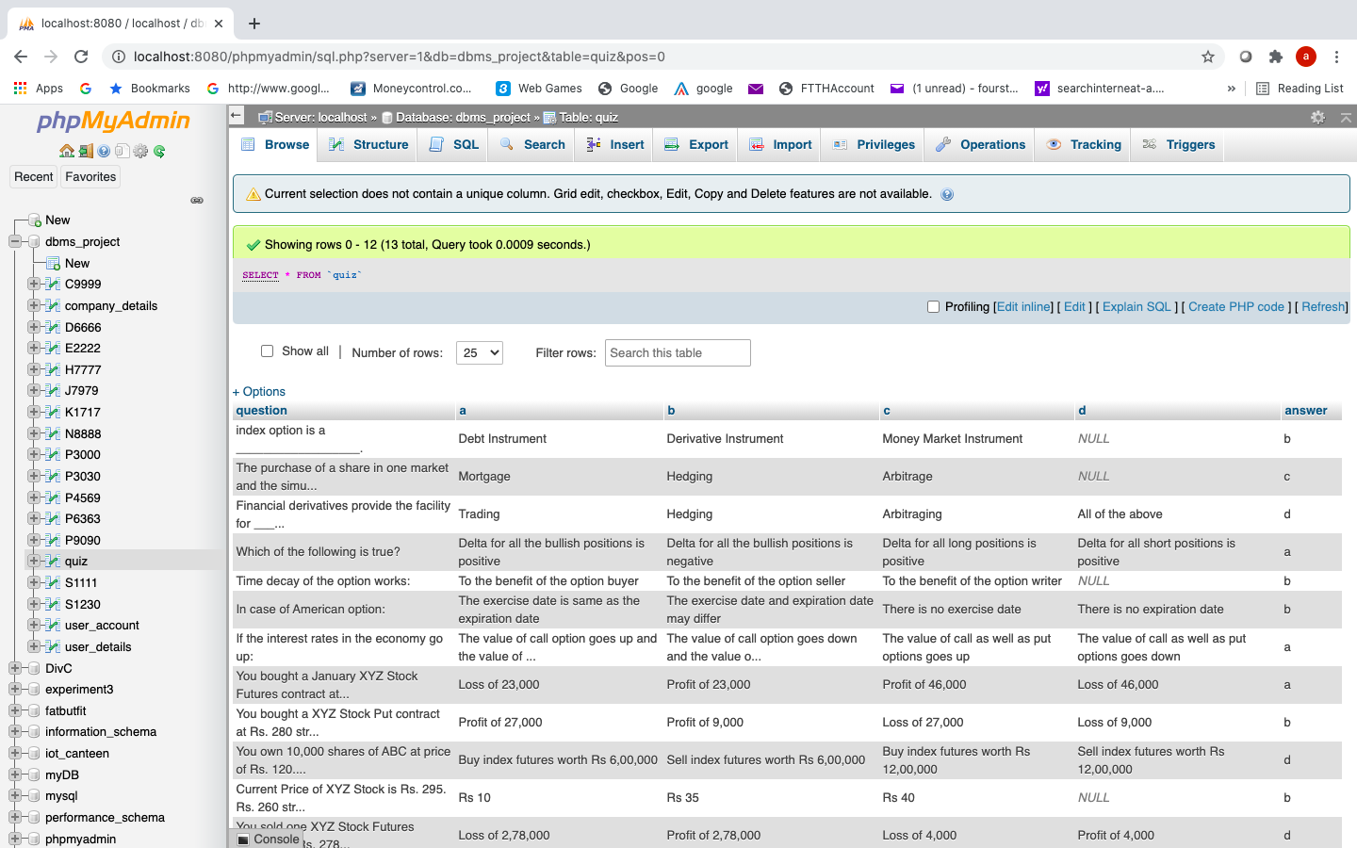Quiz table

1. **GUI/ DATABASE SCREENSHOTS**

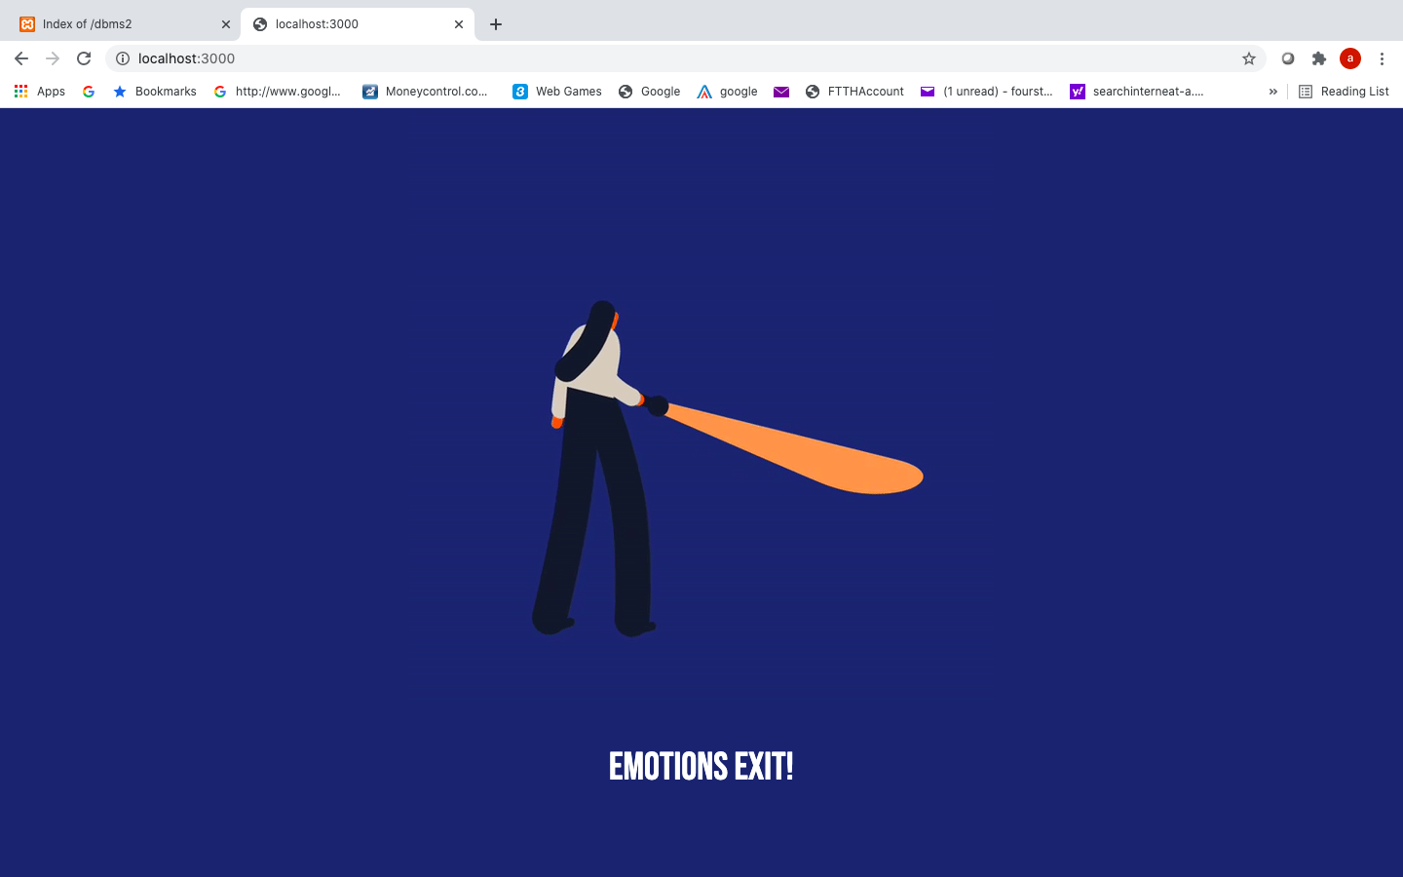

Splash screen created with node.js and express

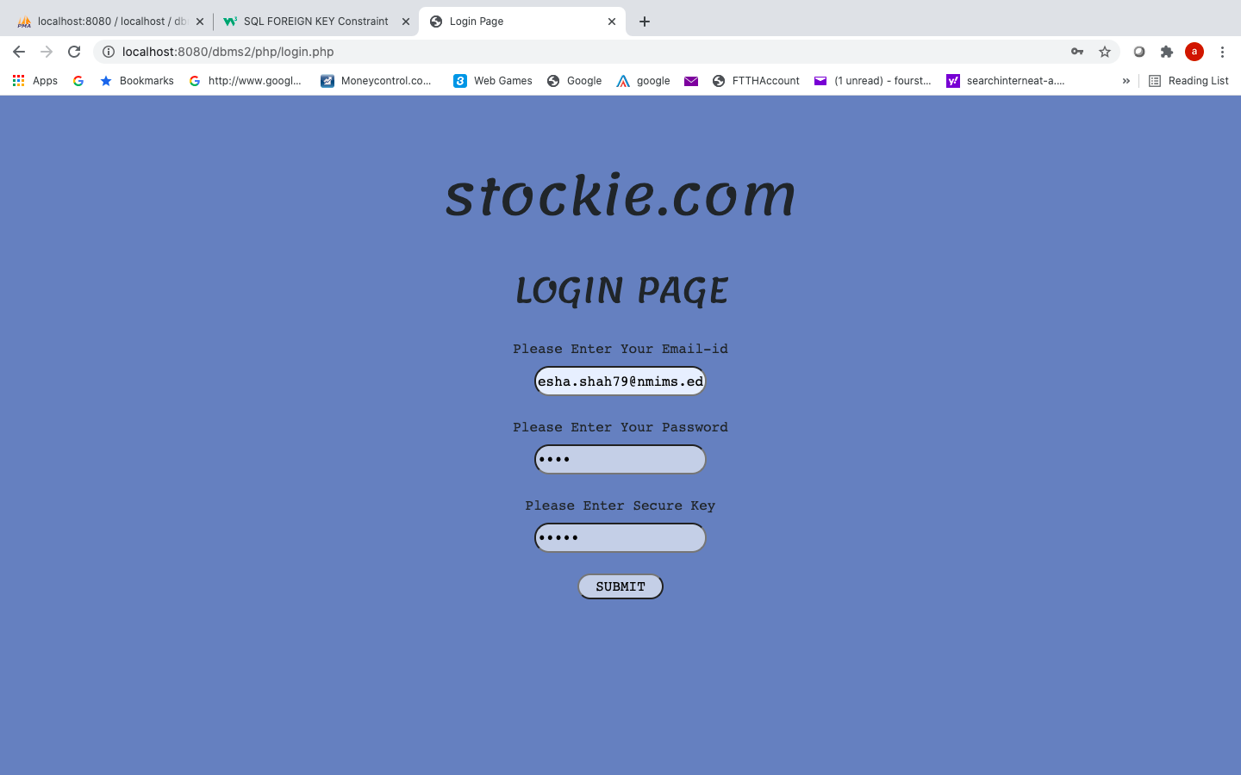

Login page with php and MySQL validation

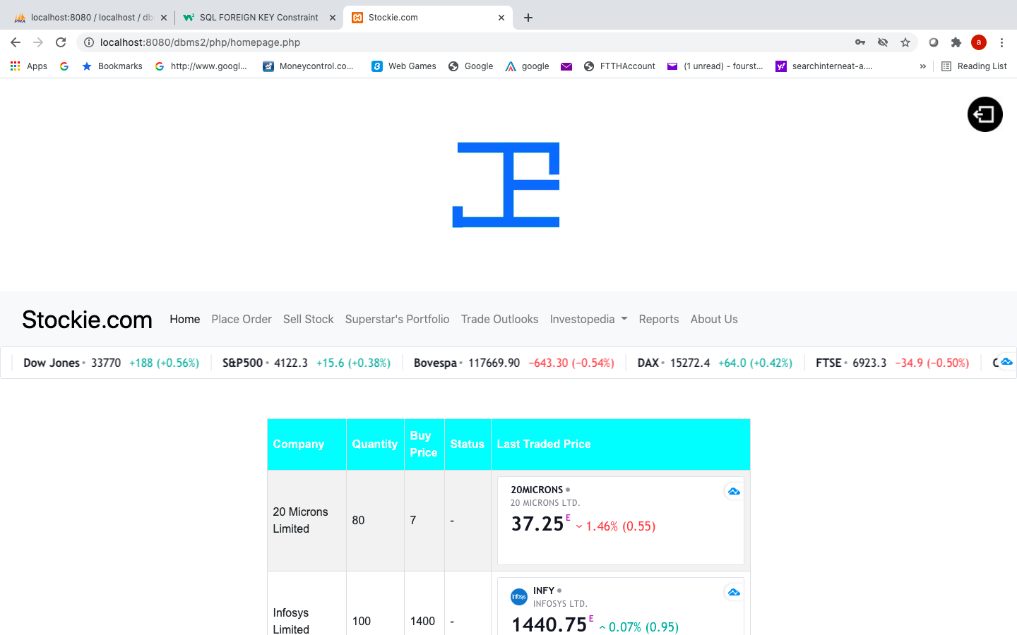

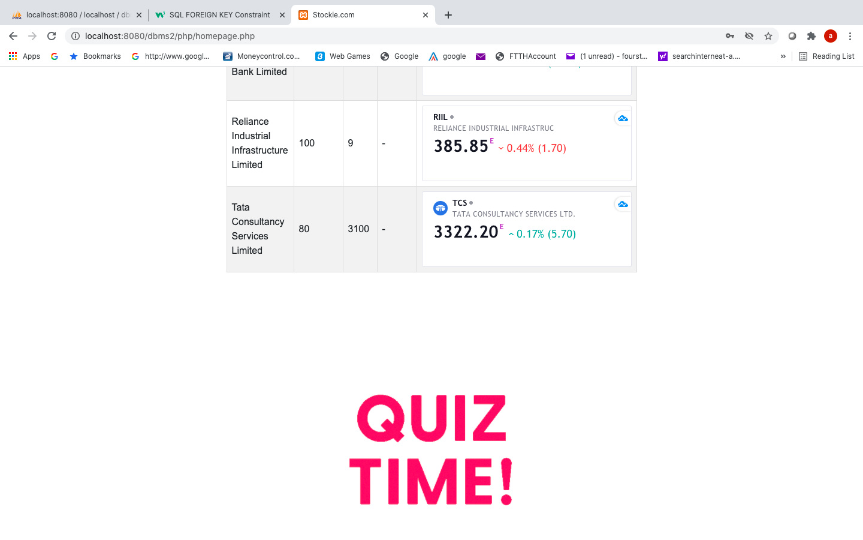

Home page with php and MySql

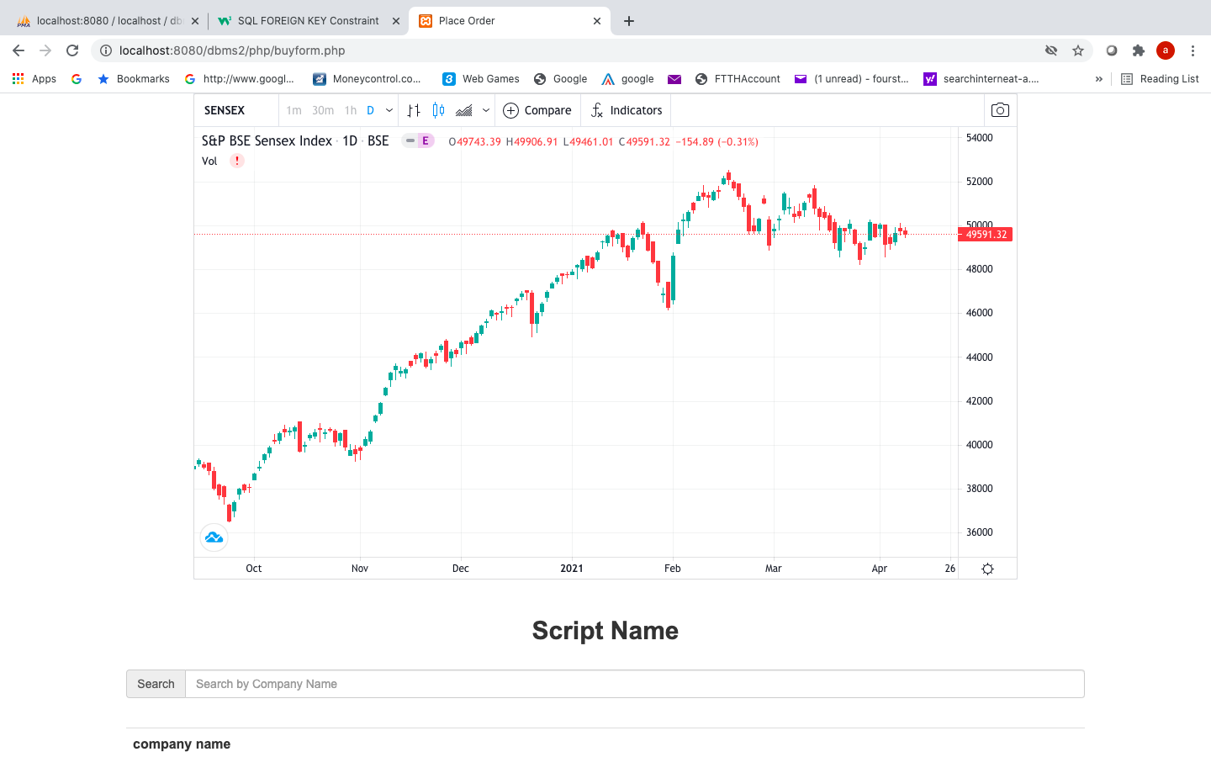

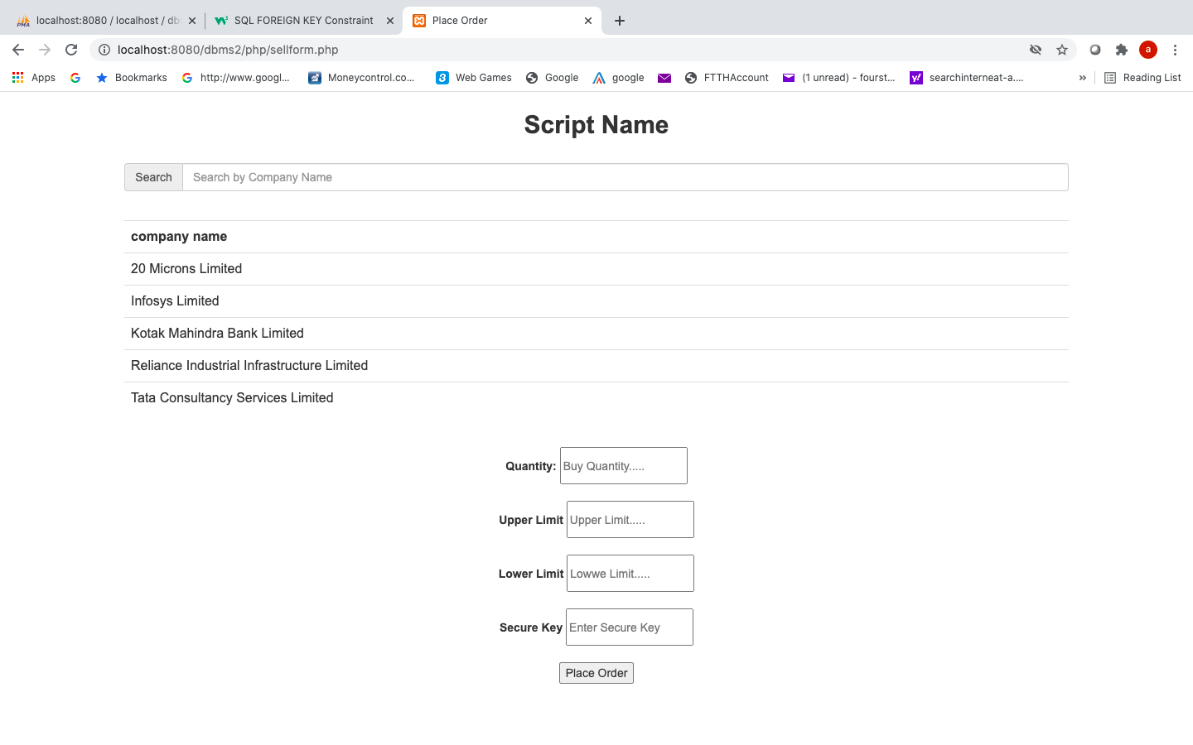

Sell form and buy form with php, mysql, ajax, transaction and CRUD operations.

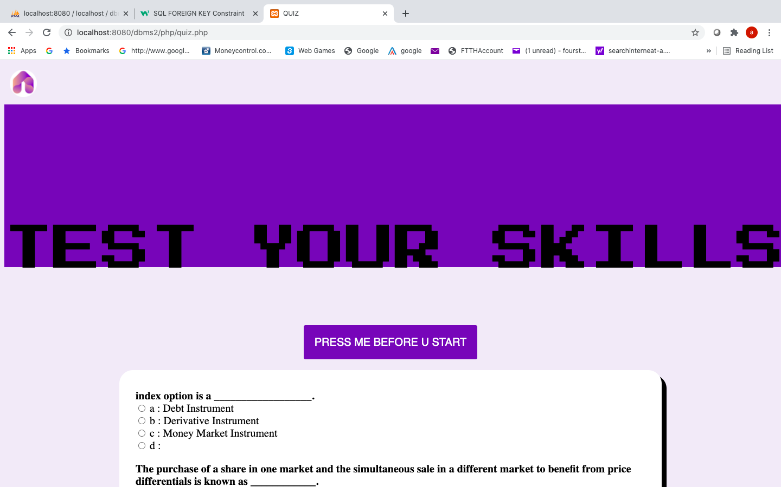

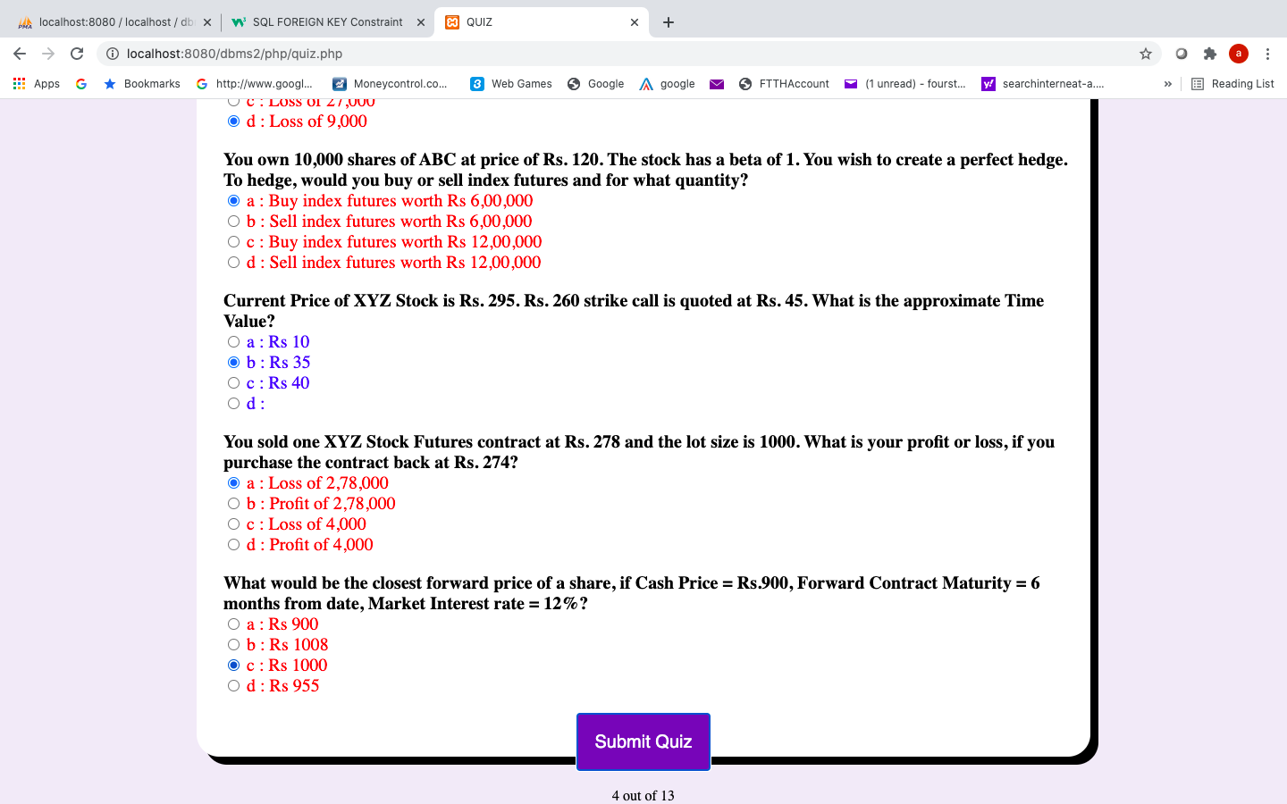

Quiz page with php, mysql and jquery

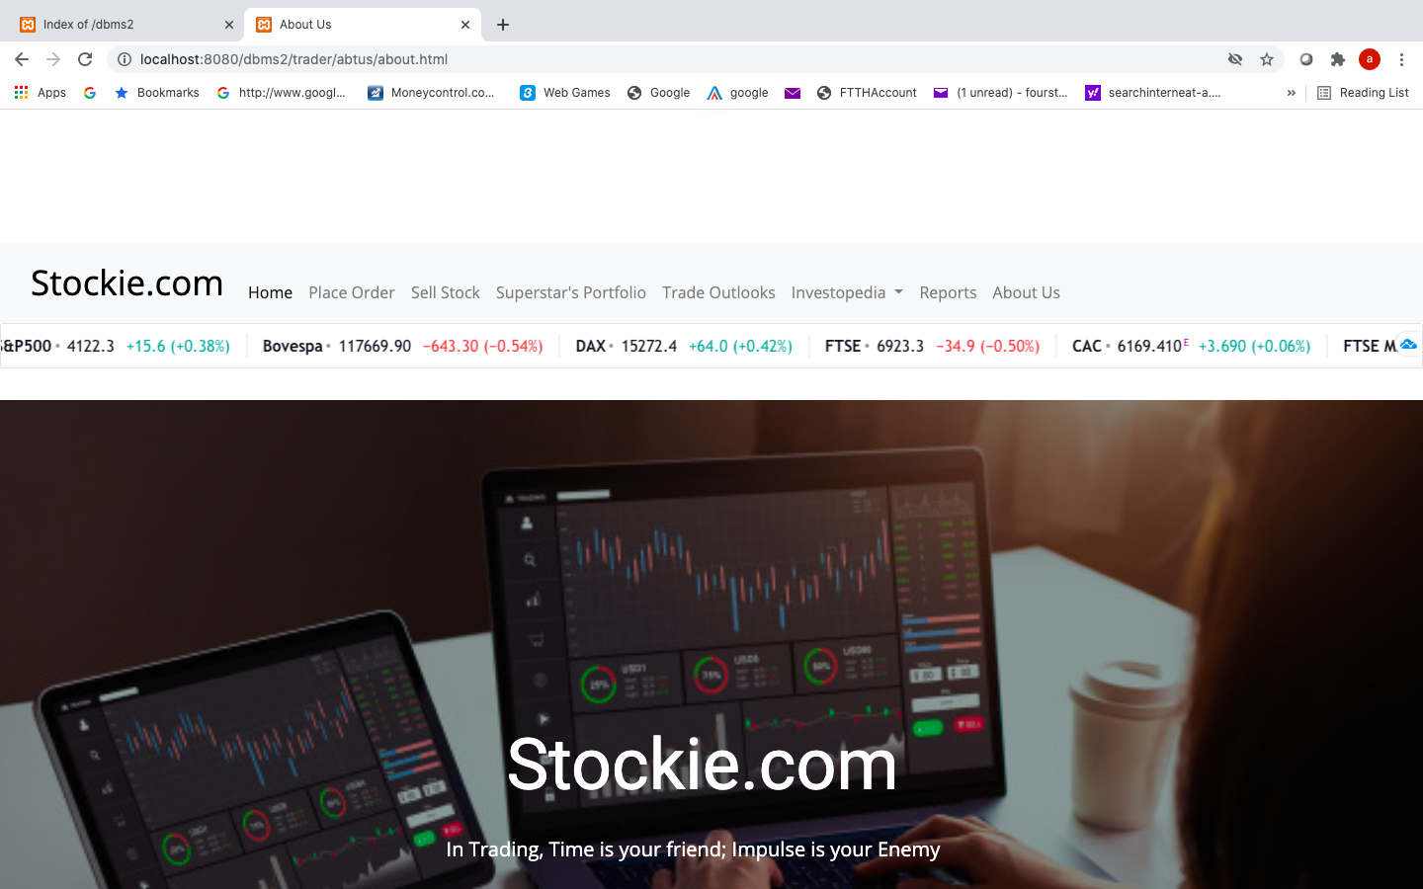

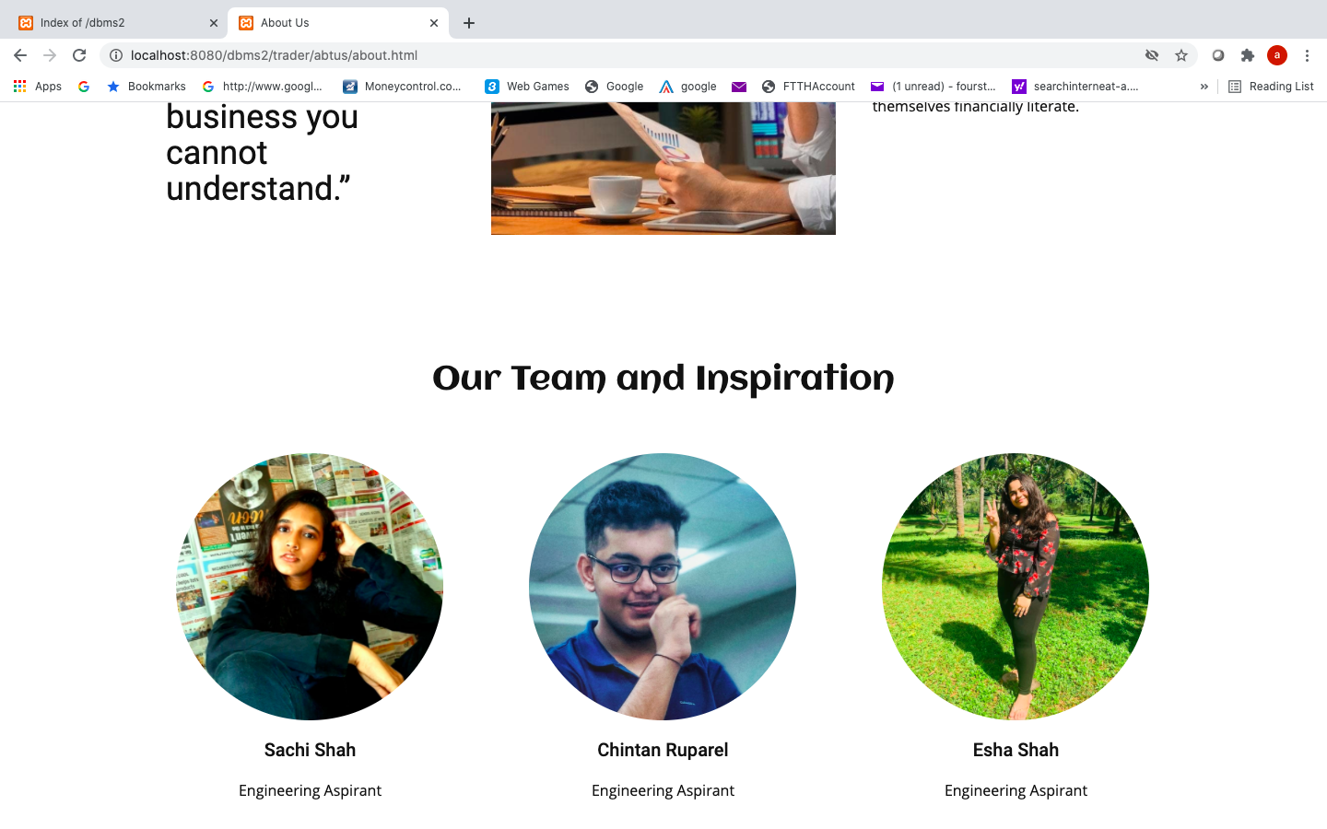

About Us page

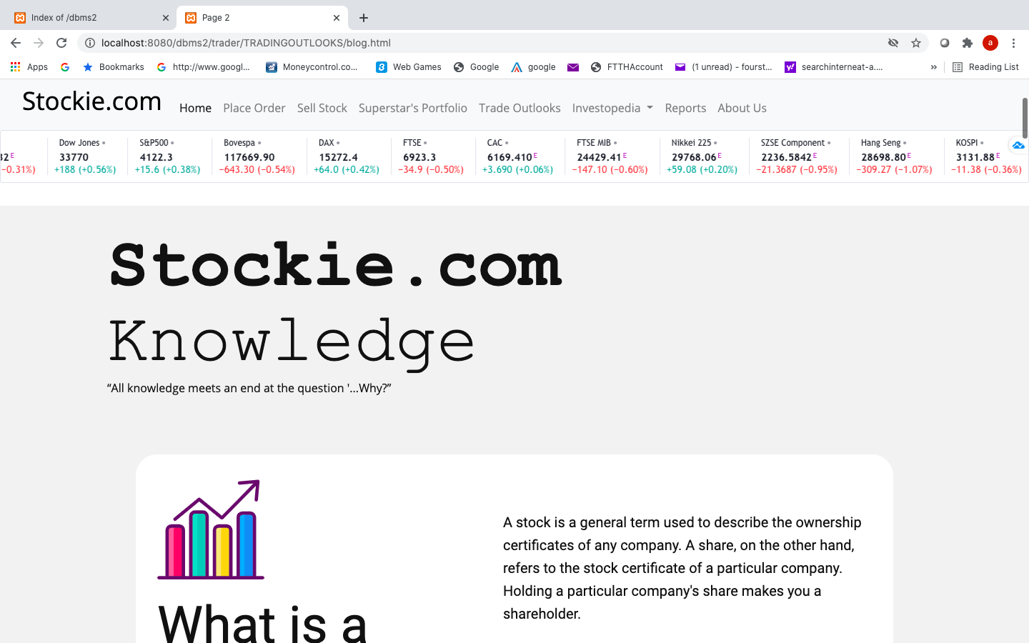

Trading Outlooks with bootstrap

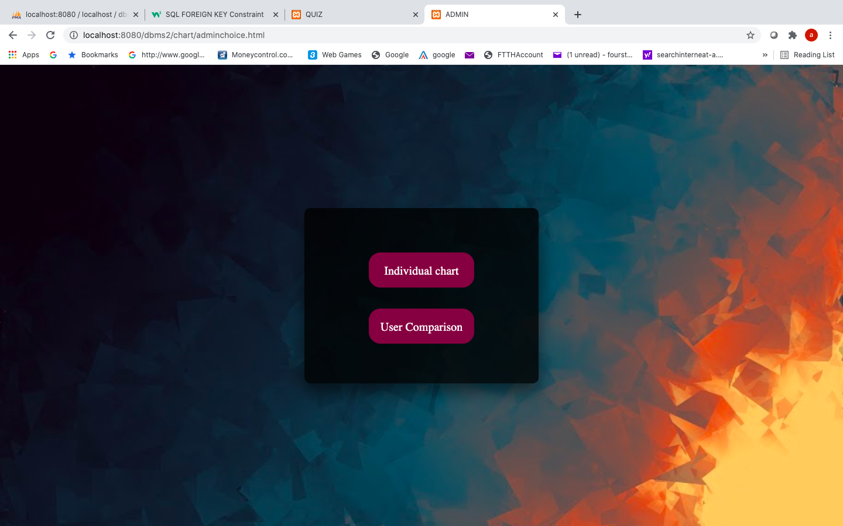

Admin Choice page

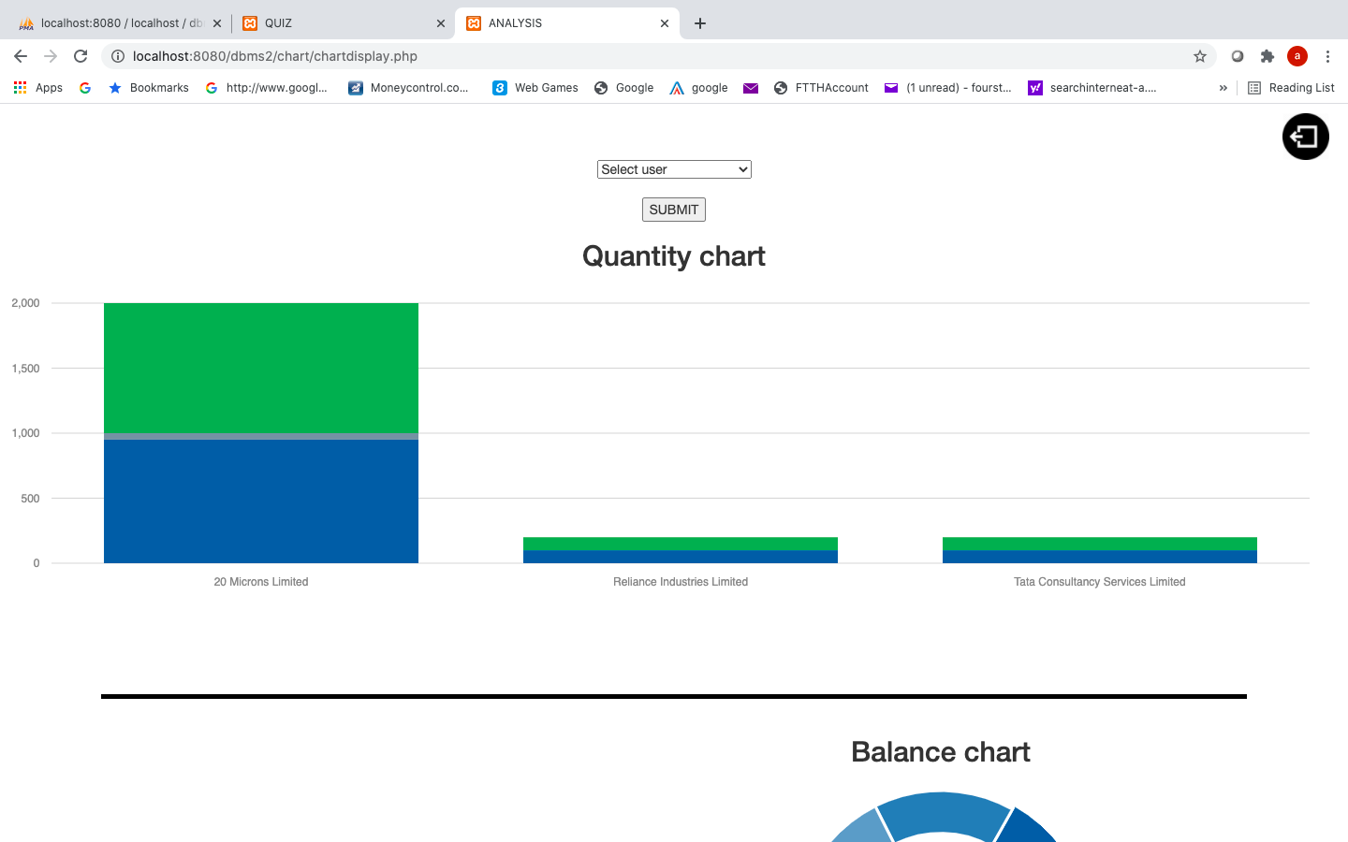

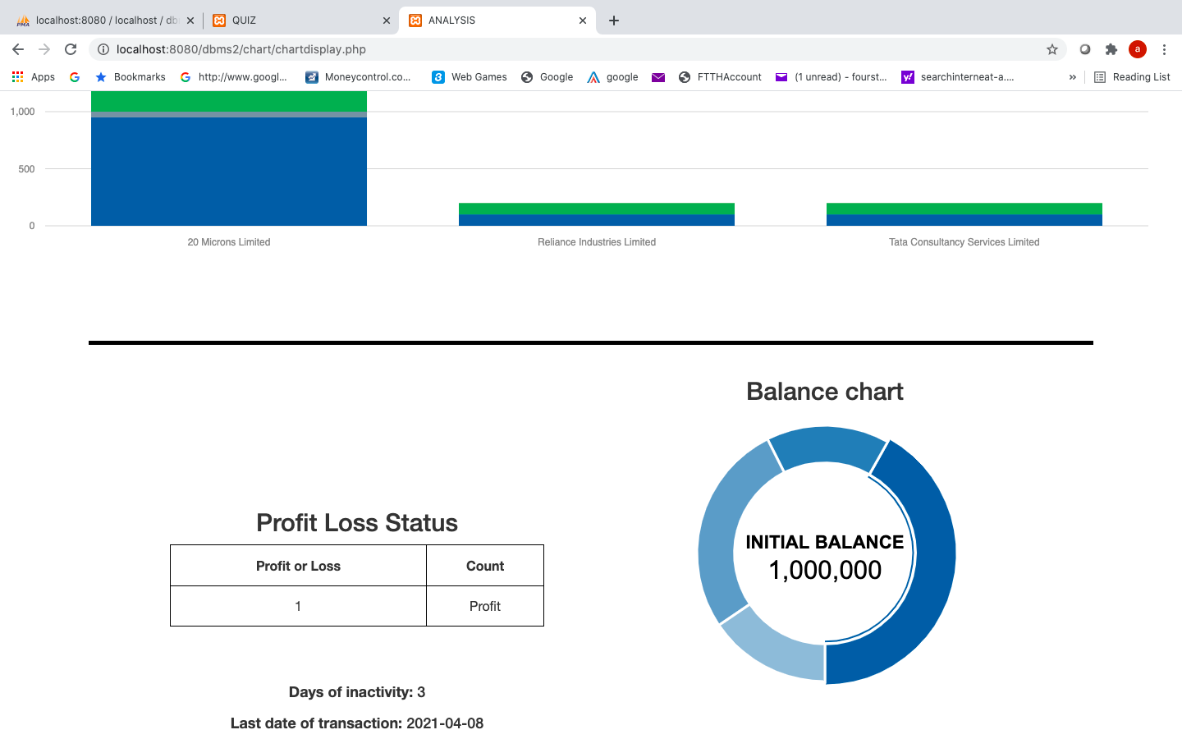

Individual chart using group by, having, datediff, max, curdate and morris charts.

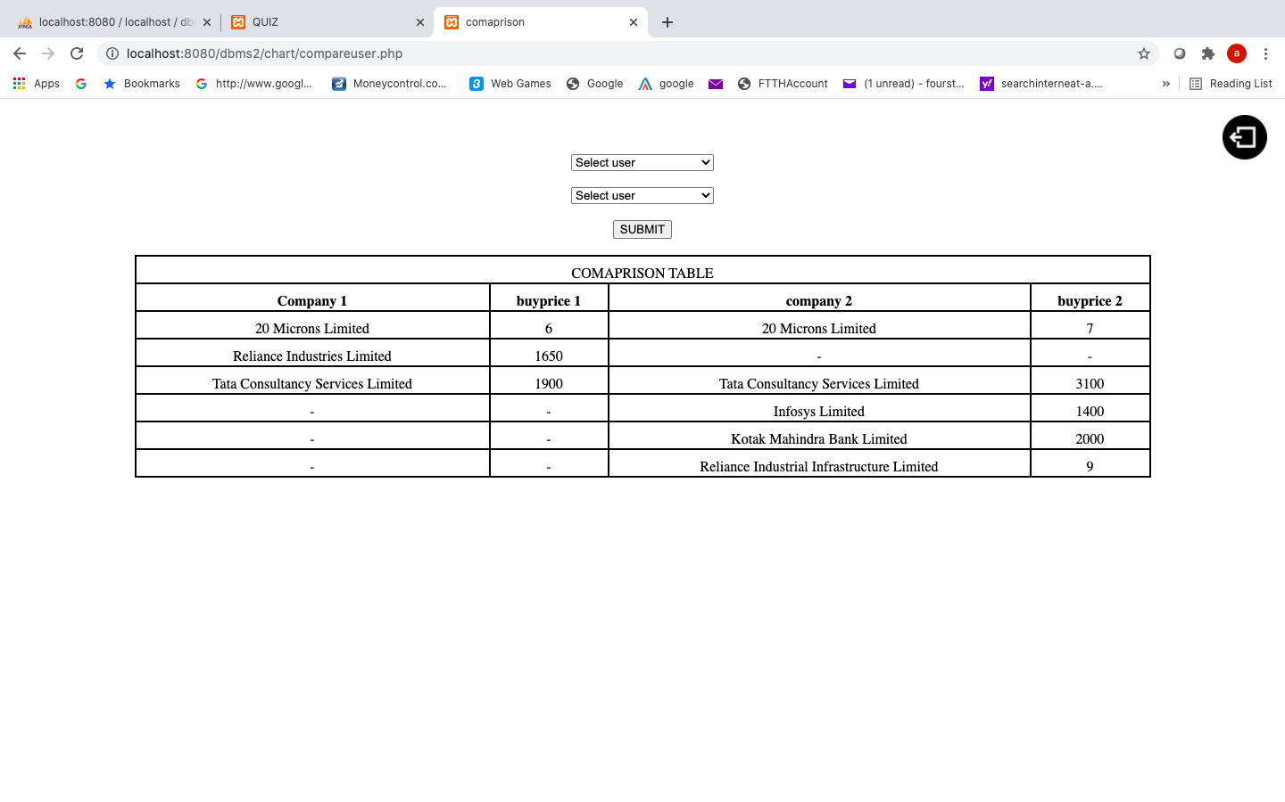

User comparison using joins

1. **CONCLUSION & FUTURE SCOPE**

Our mini project aims to get all the youngsters of today’s generation in this field of trading and get them rid from their fear of loosing in trading by giving them a mock training platform.

Future scope:

Our website is yet not complete. We would like to implement more features and help users in everyway possible. We might add a passbook which shows their transactions till date so that they can learn from their past purchases. We would like to provide monthly/weekly reports of their activity to the users so that they can analyze themselves.

We might make a about page for the website that is visible to everyone so that if people want to just know what the website is all about, then they can view all this and later login if they like the website and enjoy other facilities.

Once we have a complete website which is capable of attracting users, we shall host it soon and can also be converted to a app.

So in future, this website has a very great scope because it is the need of today where people don’t want their money to go in loss and when stocks are a thing in every household.

Here we conclude our complete description of our project. We hope that it will impart knowledge to the people it actually concerns. Our aim of making people financially independent with the help of parking their surplus money into stock market. We end it with an end note: Financial well being is the way forward. Understanding aspects about the financial world is of utmost importance and need.

We won’t stop here we will come back with something more innovative and knowledge imparting.

Till then Signing off.

1. **APPLICATIONS**

Our website is responsive so it can be used on all kinds of devices without any issue. It can also be converted into a mobile app. Can be used by all age groups. It will help in training.

New traders are often too secure about their starting capital. They won’t want to step in such a mayhem without experience and proper understanding hence this will help them gain experience without loosing anything. Secondly it will help everyone to have not only bookish knowledge about financial market but also practical knowledge.

Knowledge gaining website with a tinch of experience gained. This will help every individual gain financial independence without loosing initial capital.